April 2025

Benny’s Pet Foundation
Board of Directors

Marsha L. Brandt,
President

Diane Marcin,
Treasurer

Carol L. Cingranelli,
Member

Renee Cardinale,
Member

To Whom It May Concern:

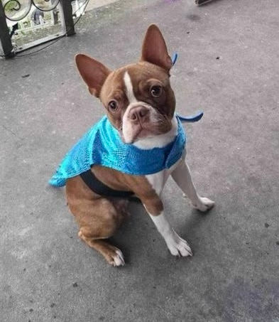
Benny’s Pet Foundation is a 501(c)(3) nonprofit organization based in our Central Pennsylvania community. BPF provides Grants to qualifying Veterinary Care Funds, Nonprofit Organizations and Nonprofit Rescues for Emergency Vet Care. In addition, we are dedicated to hosting Pet Adoption Events (Featuring Local Pet Rescues & Pet Related Vendors), as well as educating the public about general care of animals.

This letter is to request your support for Benny’s PawtoberFest – Pet Appreciation Day which will take place on Saturday, October 11th, 2025, at Benny's Pet Depot, 5202 Simpson Ferry Road, Mechanicsburg, 17050 from 10:00 AM- 2:00 PM. Benny's PawtoberFest Pet Appreciation Day is the largest fundraiser for Benny's Pet Foundation.

The event will feature over 50 vendors, Local Pet Rescues and Animal Shelters, Pet Related Vendors, Pet Food Suppliers, Pet Costume Contest & Pet Parade, DJ/Emcee, Raffle Table, 50/50 Drawing and much more!
Reggie from NEBTR – Grant Recipient

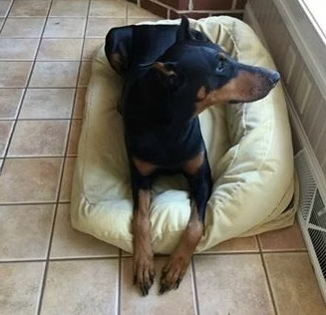
Our event will be promoted on Facebook, through flyers, e-mail blasts, through our website, as well as submitting press releases to local media.

We are reaching out to your organization to request your support by donating an item to our raffle table – this can be a gift basket, gift certificate, coupon/voucher for services, donated item or promotional item(s). The deadline for providing a donation to our raffle is Monday,
September 30th, 2025.

If you have questions, or to arrange pickup or drop off of a raffle donation, please contact Marsha Brandt, 2025 Benny’s PawtoberFest Event Chair, at 717-557-6810 or by e-mail bennyspetfoundation@gmail.com.
Sasha from Doberman Pinscher Rescue of PA Our very first Grant Recipient.
Benny’s Pet Foundation is a 501(c)3 Non-Profit Organization. Tax ID #81-1127024

Most sincerely,

Marsha Brandt
President & Cofounder of Benny’s Pet Foundation

