On Saturday, October 11th, 2025, Benny’s Pet Foundation (BPF) will be holding our annual event; Benny’s PawtoberFest – Pet Appreciation Day. Benny's PawtoberFest Pet Appreciation Day is the largest fundraiser for Benny's Pet Foundation (BPF). The event will feature over 50 vendors, featuring Local Rescues and Shelters, Pet Related Vendors, Pet Food Suppliers, Pet Costume Contest & Pet Parade, DJ/Emcee, Raffle Table, 50/50 Drawing and much more!
Benny’s Pet Foundation
Board of Directors

Marsha L. Brandt,
President

Diane Marcin,
Treasurer

Carol L. Cingranelli,
Member

Renee Cardinale,
Member

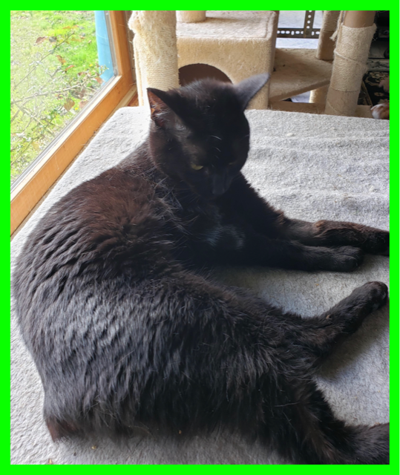
Ellie from Loving Care Cat Rescues –
Grant Recipient

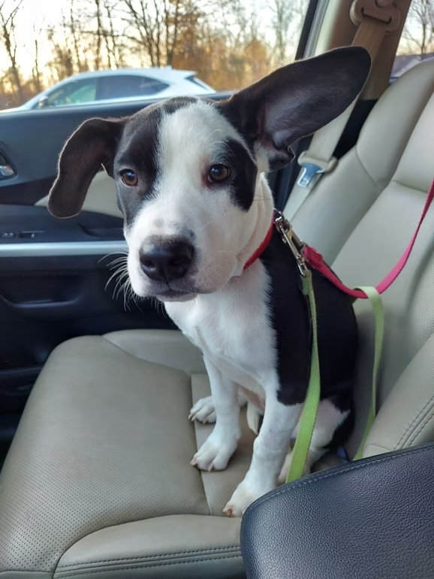
Lizzie from Furry Friends Network –
Grant Recipient

Registration is FREE for ALL Non-Profit Organizations (501(c)(3) Determination Letter is Required). There is a Registration Fee for Food Trucks and For-Profit Businesses, this Fee is Tax-Deductible. All vendors are responsible for bringing their own tables, chairs, canopy (weights for your canopy) and any material to promote your Rescue, Organization and/or Business. We will have volunteers available to help unload and load items and assist with putting up your canopy. We ask that ALL Rescues and Vendors stay for the entire event. Rescues and Shelters, please have one handler/volunteer for each adoptable pet that you will have at the event.

Benny’s PawtoberFest Vendor Details:
Online Registration: Opens Wednesday, May 1st, 2025.
Date: Saturday, October 11th, 2025 / 10:00 am to 2:00 pm (RAIN OR SHINE)
Location: Benny’s PET DEPOT / 5202 Simpson Ferry Road / Mechanicsburg, PA 17050
Vendor Set Up: 8:00 am – 9:45 am
Absolutely No Pet Sales / No Electricity Provided /All Pets Must Be on a Leash of 6FT or Less - No Retractable Leashes

BPF will also host a Food Table featuring Homestyle Soups and Bake Sale. We will also have a raffle table featuring many different items and services as well as a 50/50 drawing with All Proceeds Benefiting Benny’s Pet Foundation.

For more information about BPF please visit our website www.bennyspetfoundation.org or email benny@bennyspetfoundation.org. We look forward to hearing back from you and hope your rescue/organization will be able to join us.

Thank you, Marsha Brandt President and Cofounder of Benny’s Pet Foundation

