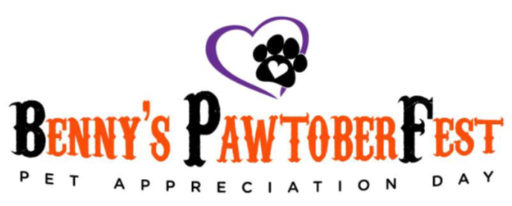
Donated Goods Verification Form
(Please Complete the following form if you are making a non -monetary donation)
Event: Benny’s PawtoberFest – Pet Appreciation Day
Date of Event: Saturday, October 12th, 2024
Name of Business/Company: _________________________________________________________
Address:__________________________________________________________________________
City:______________________________ State:____________ Zip:___________________________

Phone: ______________________Fax: _______________ Email: ____________________________

Contact Person and Title: ____________________________________________________________

Signature: _______________________________________________ Date: ____________________

Description of Donated Goods: ________________________________________________________
__________________________________________________________________________________

Estimated Value of Donated Goods: ____________________________________________________

Donated Goods: ________ Business is Dropping Off ________ Volunteer Needs to Pickup

5202 Simpson Ferry Rd #102, Mechanicsburg, PA 17050
Email: bennyspetfoundation@gmail.com www.bennyspetfoundation.org

